COMPUTER NETWORKS - CSA0763

NAME: M.SAI SRI RAM

REG .NO: 192211366

1. Configuration of Network Devices using Packet Tracer (Hub, Switch, Ethernet, Broadcast)

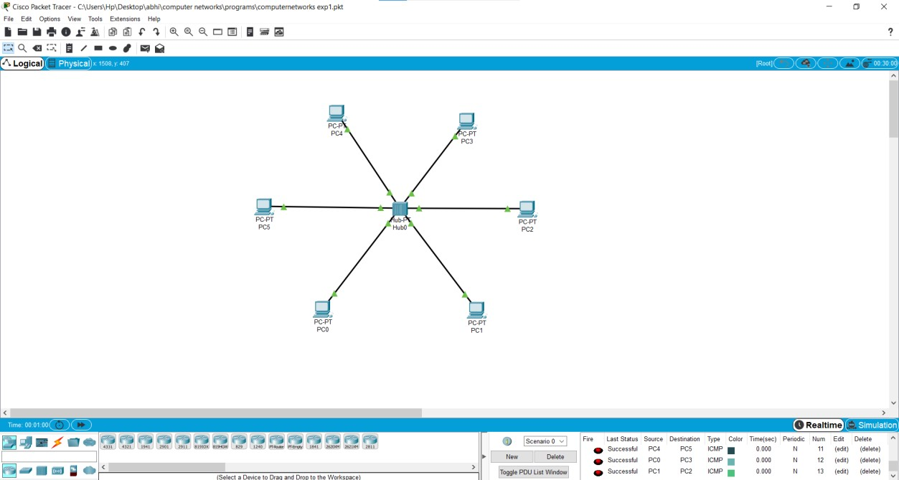

1. Configuration of Topologies using Packet Tracer (Star, Mesh, Tree,)

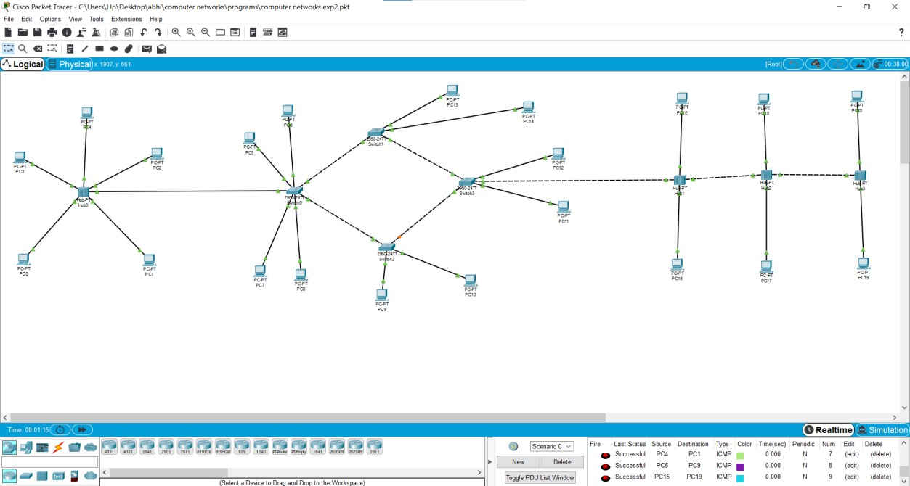

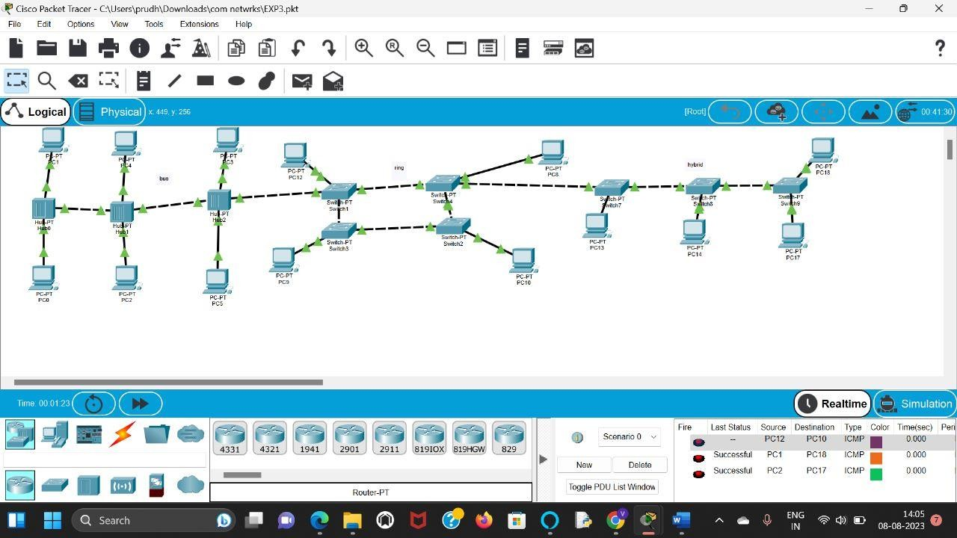

**4.** Data Link Layer Traffic Simulation using Packet Tracer Analysis of CSMA/CD& CSMA/CA

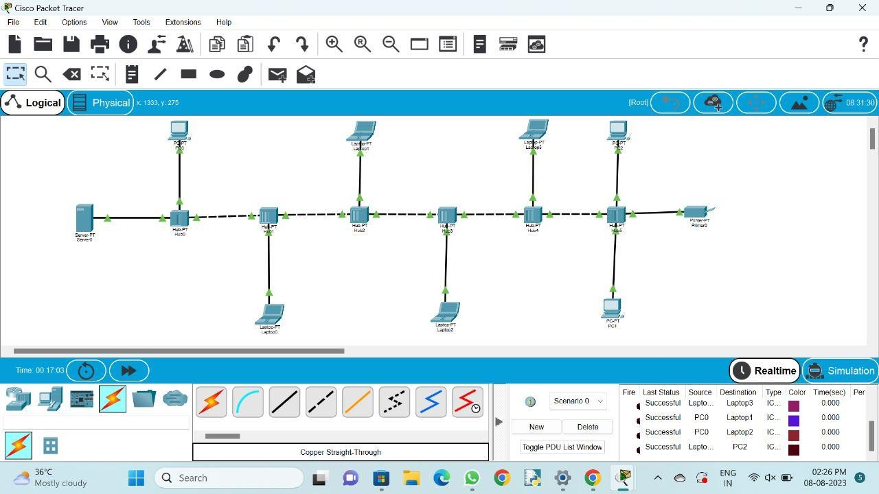

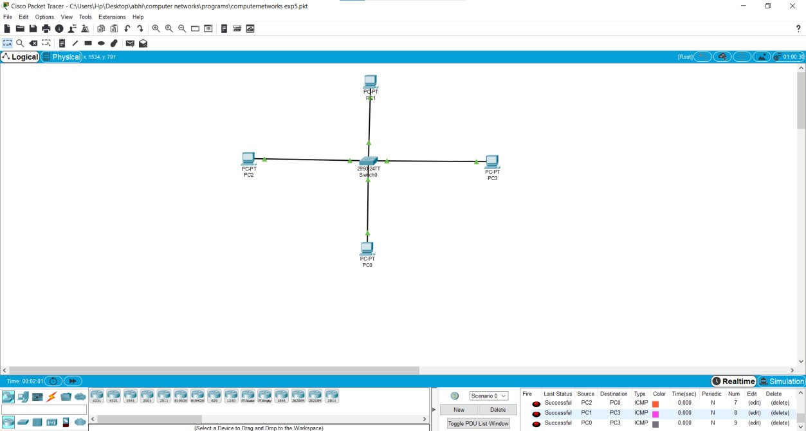

**6.** Static Routing using Packet Tracer

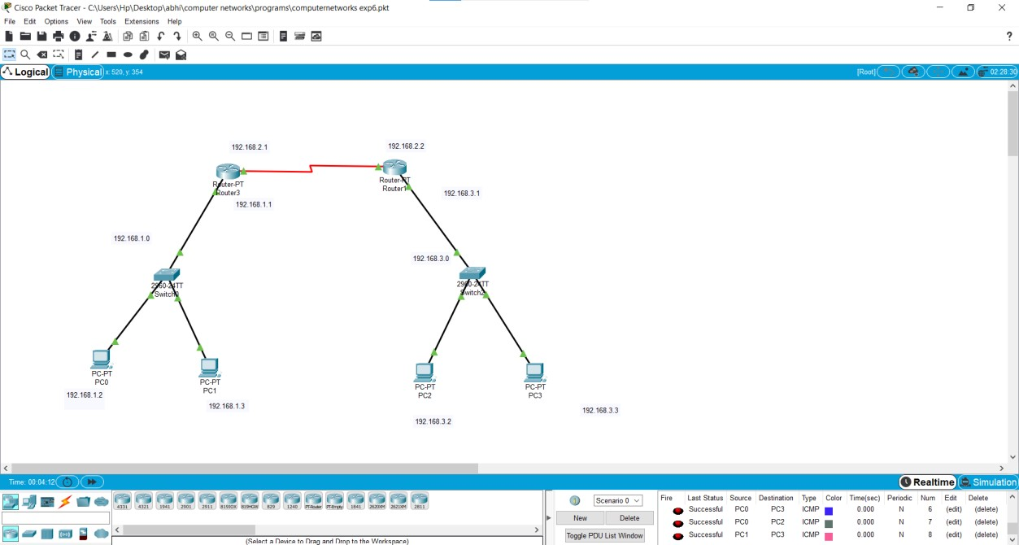

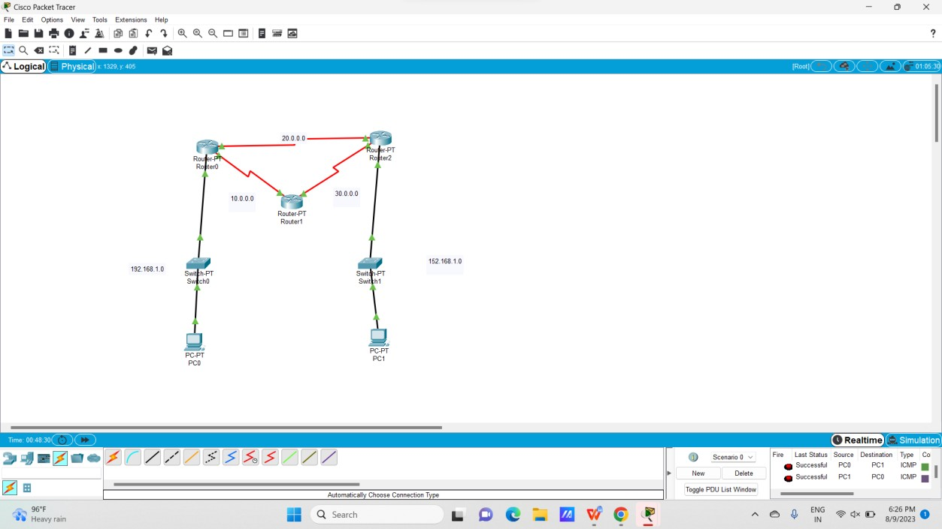

**8.** Subnetting – Class C Addressing

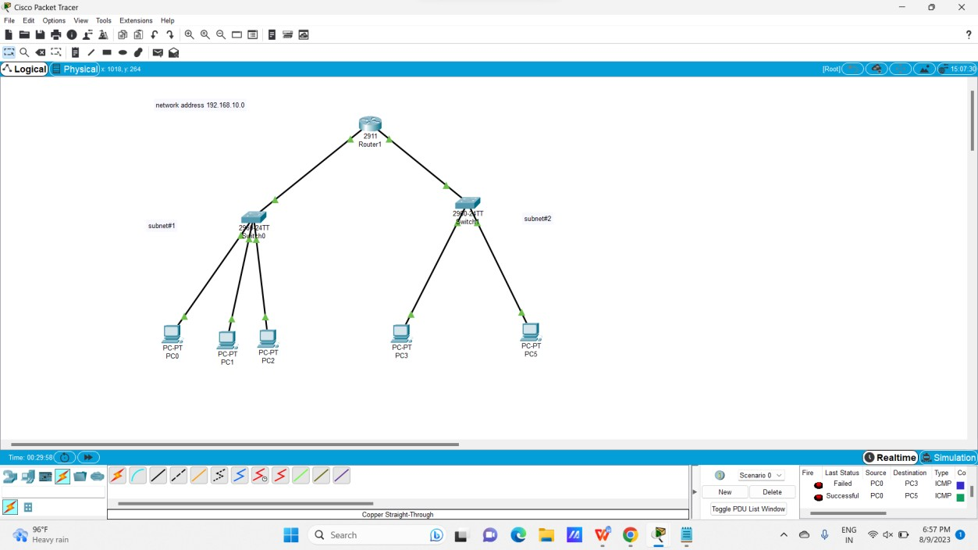

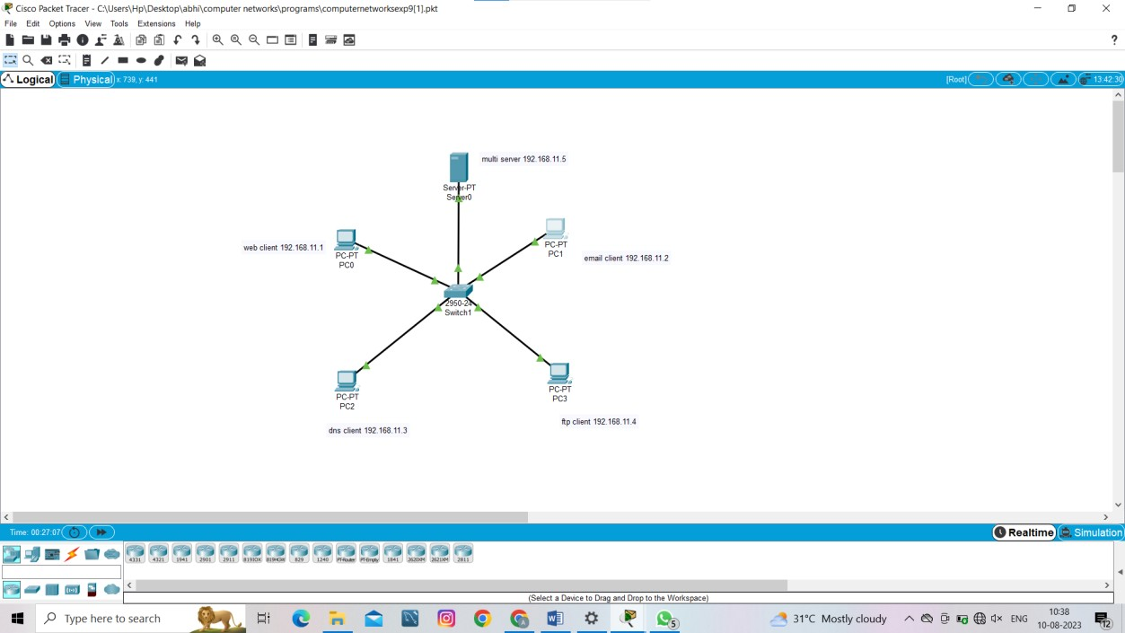

**10.** TCP, UDP Exploration Solution

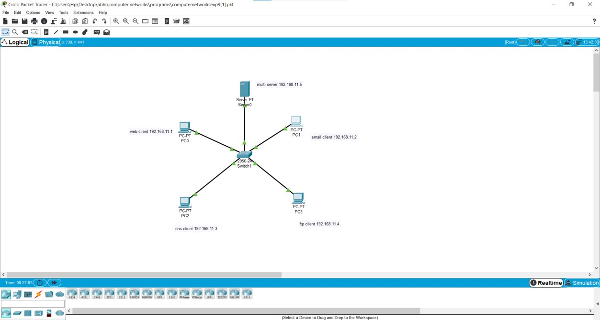

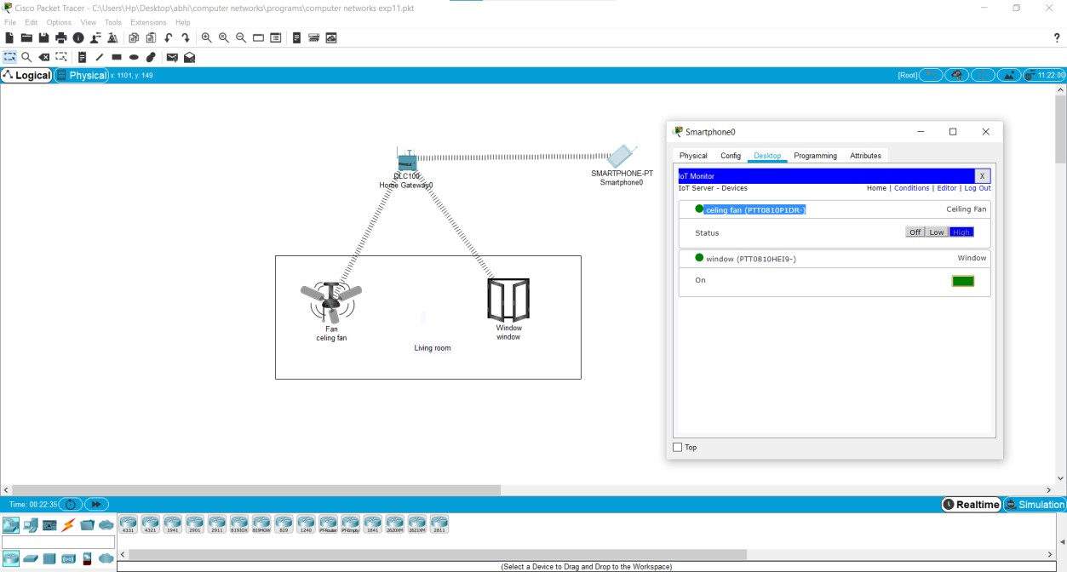

**12.** Smart Garden in Cisco Packet Tracer

